**Cycle 7**

**Program 1**

**Aim :** Write a Python program to read a file line by line and store it into a list.

**Source code :**

def read_file_into_list(filename):

with open(filename, 'r') as file:

lines = file.readlines()

return [line.strip() for line in lines]

filename = "example.txt"

lines_list = read_file_into_list(filename)

print(lines_list)

example.txt

Hello, this is the first line.

This is the second line.

Here comes the third line.

And finally, the fourth line.

**Output :**



**Program 2**

**Aim :** Python program to copy odd lines of one file to other.

**Source code :**

def copy_odd_lines(source_file, destination_file):

with open(source_file, 'r') as src:

lines = src.readlines()

with open(destination_file, 'w') as dest:

for i in range(0, len(lines), 2):

dest.write(lines[i])

source = "example.txt"

destination = "odd_lines.txt"

copy_odd_lines(source, destination)

print("Odd lines have been copied.")

example.txt

Hello, this is the first line.

This is the second line.

Here comes the third line.

And finally, the fourth line.

**Output :**



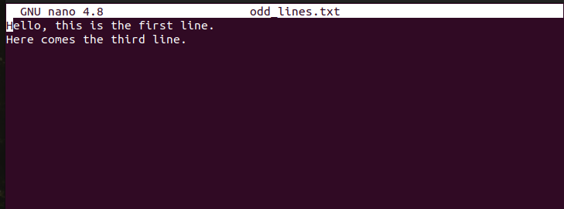

**Program 3**

**Aim :** Write a Python program to read each row from a given csv file and print a list of strings.

**Source code :**

import csv

def read_csv_file(filename):

with open(filename, mode='r', newline='') as file:

reader = csv.reader(file)

for row in reader:

print(row)

csv_filename = "example.csv"

read_csv_file(csv_filename)

example.csv

Hello, this is the first line.

This is the second line.

Here comes the third line.

And finally, the fourth line.

**Output :**

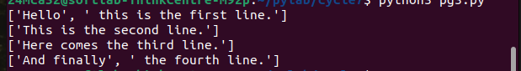

**Program 4**

**Aim :** Write a Python program to read specific columns of a given CSV file and print the content of the columns.

**Source code :**

import csv

def read_specific_columns(filename, columns):

with open(filename, mode='r', newline='') as file:

reader = csv.reader(file)

for row in reader:

try:

selected_columns = [row[i] for i in columns]

print(selected_columns)

except IndexError:

print("Error: One of the specified column indices is out of range.")

csv_filename = "data.csv"

columns_to_read = [0, 2]

read_specific_columns(csv_filename, columns_to_read)

data.csv

Name, Age, City

Johhana , 28, New York

Anna, 22, London

Peter parker , 34, Berlin

Maria, 25, Madrid

David, 30, Paris

**Output :**

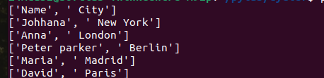

**Program 5**

**Aim :** Write a Python program to write a Python dictionary to a csv file. After writing the CSV file, read the CSV file and display the content.

**Source code :**

**i**mport csv

def write_dict_to_csv(filename, data):

with open(filename, mode='w', newline='') as file:

writer = csv.DictWriter(file, fieldnames=data[0].keys())

writer.writeheader()

writer.writerows(data)

def read_csv_file(filename):

with open(filename, mode='r', newline='') as file:

reader = csv.DictReader(file)

for row in reader:

print(row)

dict_data = [

{'Name': 'John', 'Age': 28, 'City': 'New York'},

{'Name': 'Anna', 'Age': 22, 'City': 'London'},

{'Name': 'Peter', 'Age': 34, 'City': 'Berlin'}

]

csv_filename = "output.csv"

write_dict_to_csv(csv_filename, dict_data)

print("Data has been written to the CSV file.")

print("CSV file content:")

read_csv_file(csv_filename)

**Output :**

